27U ENCLOSURE 19" CABINET 800X600 FLOOR STANDING DATA RACK - ECO NETCAB
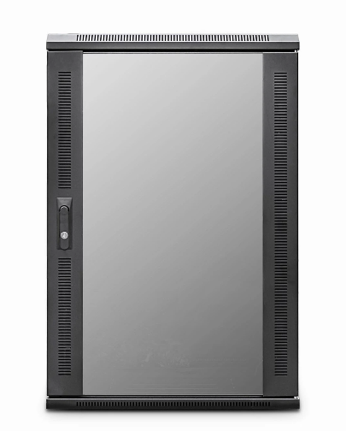

DESCRIPTION
Quality and flexibility with bundled accessories to help make your enterprise
level installations much more cost-effective.
The new LMS Data EcoNetCab range of Enterprise-level data cabinets, all of which
are professionally assembled in the UK come with the quality and features you’ve
come to expect from LMS Data. Available for a choice of professional
installation scenarios, built from the ground up with quality alloys, robust
powder coating and of course features to make pre and post installation easy,
including adjustable front and rear ETSI 19-inch mount posts, gland plates,
removable side panels and left/right hinged front safety glass door and solid
rear door.
Supplied as standard with a host of fitted accessories including fitted fan tray,
front cable management tray, vented shelf, castors and jacking feet together with M6
captive nut and bolt kit. Saving you both time and money for
all your professional data installations.

SPECIFICATIONS
27U high 800W 600D
ETSI 19” front/rear profiles, adjustable
Lockable vented glass door, reversible
Fitted 2-way fan tray
Removable side panels, rear lockable door
Integral Front Cable Management fitted
Ideal for Data Centres, IT rooms, SME
Fitted castors and jacking feet (4)
UK Assembled and quality assured

TECHNICAL INFO
SKU/MPN: CAB-FE-27U-86
EAN: 8400800023575
Weight: 90kg
Dimensions: 800 (width) x600 (depth) x1370mm (height)

FILES
Datasheet - CAB-FE-27U-86

